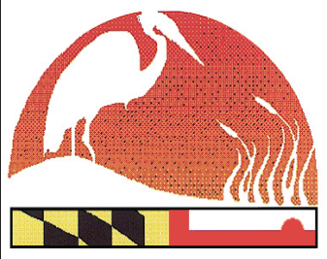
The Maryland Envirothon

12407 Naves Cross Road NE
Cumberland, Maryland 21502
(240)-609-3508
chartsock@atlanticbbn.net

mdenvirothon
www.mdenvirothon.org

2021 Virtual Maryland Envirothon
Schedule of Events

TRAINING SCHEDULE

Prior to the competition, Resource Professionals from Aquatics, Forestry, Soils and Wildlife will be offering virtual training sessions, at which time students will be able to ask questions. Prior to attending the training sessions, students are encouraged to watch the training videos for each resource area, which will be posted on the Maryland Envirothon website and also on YouTube. Following is the training schedule;

AQUATICS – Wednesday March 31, 6PM FORESTRY – Friday April 2, 6PM
Friday April 9, 6PM Wednesday April 7, 6PM

WILDLIFE – Friday March 26, 6PM SOILS – Tuesday April 6, 6PM
Thursday April 1, 6PM

COMPETITION SCHEDULE

SOILS – Monday, April 26, 9AM – 9PM

FORESTRY – Tuesday April 27, 9AM – 9PM

WILDLIFE – Wednesday April 28, 9AM – 9PM

AQUATICS – Thursday April 29, 9AM – 9PM

KICK OFF EVENT/FUN ACTIVITY
Sunday April 25, 7 – 8:30 PM
(Details to Follow)

VIRTUAL AWARDS CEREMONY
Thursday May 6, 7PM
(Details to Follow)

