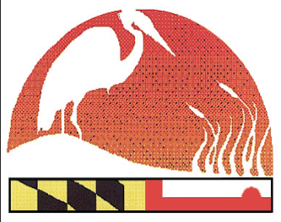
2021 Maryland Envirothon Team Participation Form
www.mdenvirothon.org
The Maryland Envirothon

12407 Naves Cross Road NE
Cumberland, Maryland 21502
(240)-609-3508
chartsock@atlanticbbn.net

PLEASE TYPE
(All information is REQUIRED)
Return by March 15, 2021

County: _____________________ School (entire name): _______________________________
Team Name: __________________________________________________________
Address: _____________________________ City/State/Zip: ____________________________
Phone: ________________________________
Team Captain Name: ______________________________________

*Note: Advisors/Coach/Chaperone (Names & Cell phone numbers are REQUIRED):

Male | Female
Name: ________________________________ | Name: ________________________________
County: _______________________________ | County: _______________________________
Cell: ________________________________ | Cell: ________________________________
Email Address: _________________________ | Email Address: _________________________

*List Student’s Grade, Gender and T-Shirt Size Next To Student’s Name.
Students:
- Grade___ M or F size__

- Grade___ M or F size__

- Grade___ M or F size__

- Grade___ M or F size__

- Grade___ M or F size__

Advisors/Coach/Chaperone

- M or F size__

- M or F size__

